ASSIGNMENT NO.6: Data Manipulation and Table Management

QUESTION 1
Q1) Create a MySQL database named CollegeDB and create two tables: Course and Student. Course Table Column Name Data Type Constraint CourseID INT PRIMARY KEY CourseName VARCHAR(50) NOT NULL Fees DECIMAL(10,2) NOT
NULL Student Table Column Name Data Type Constraint StudentID INT PRIMARY KEY StudentName VARCHAR(50) NOT NULL Age INT City VARCHAR(30) CourseID INT FOREIGN KEY

Query

CREATE TABLE Course ( CourseID INT PRIMARY KEY,
CourseName VARCHAR(50) NOT NUll, fees Decimal (10,2) NOT NUll
);

CREATE Table Student ( StudentID INT PRIMARY KEY,
studentName VARCHAR(50) NOT null, Age INT,
city VARCHAR(30),
CourseID INT,
FOREIGN KEY (CourseID) REFERENCES course(CourseID);

QUESTION2
Q2) Insert at least 4 records into the Course table and 6 records into the Student table. B.SC. DATA SCIENCE Make sure every student has a valid CourseID from the Course table.

QUERY
INSERT INTO Course (CourseID, CourseName, Fees) VALUES
(101, 'B.Sc. Data Science', 45000.00),
(102, 'BCA', 40000.00),
(103, 'BBA', 38000.00),
(104, 'B.Com', 35000.00);
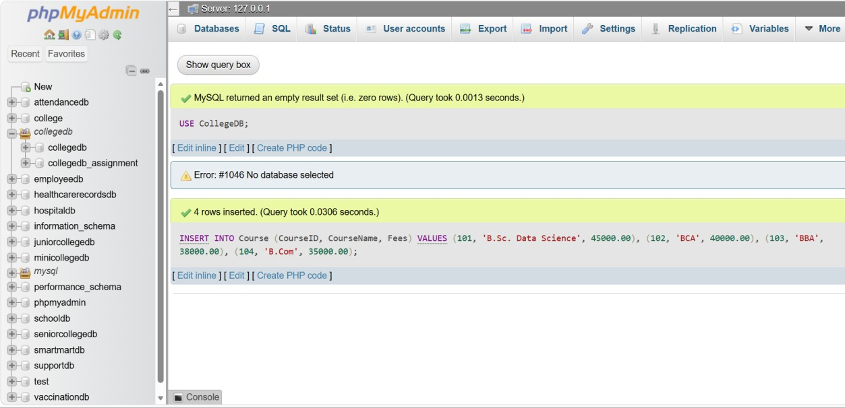
INSERT INTO Student (StudentID, StudentName, Age, City, CourseID) VALUES
(1, 'Aarav Sharma', 19, 'Pune', 101),
(2, 'Sneha Patil', 20, 'Nashik', 101),
(3, 'Rahul Joshi', 19, 'Mumbai', 102),
(4, 'Priya Shah', 21, 'Pune', 103),
(5, 'Rohan Deshmukh', 20, 'Nagpur', 104),

(6, 'Ananya Kulkarni', 19, 'Pune', 102);
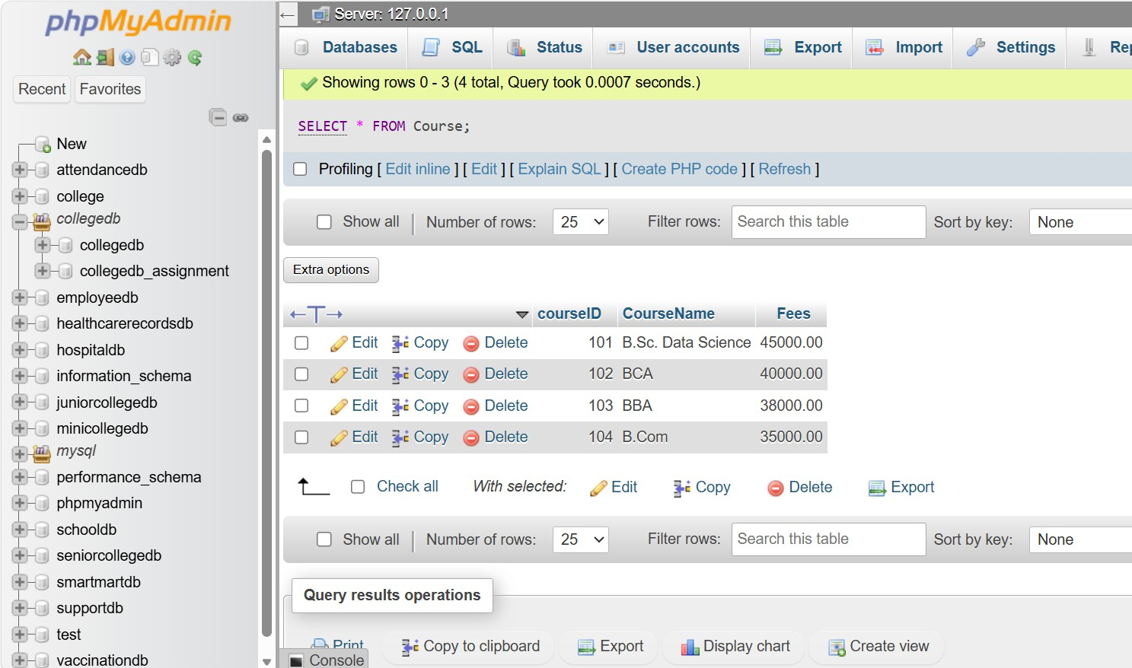
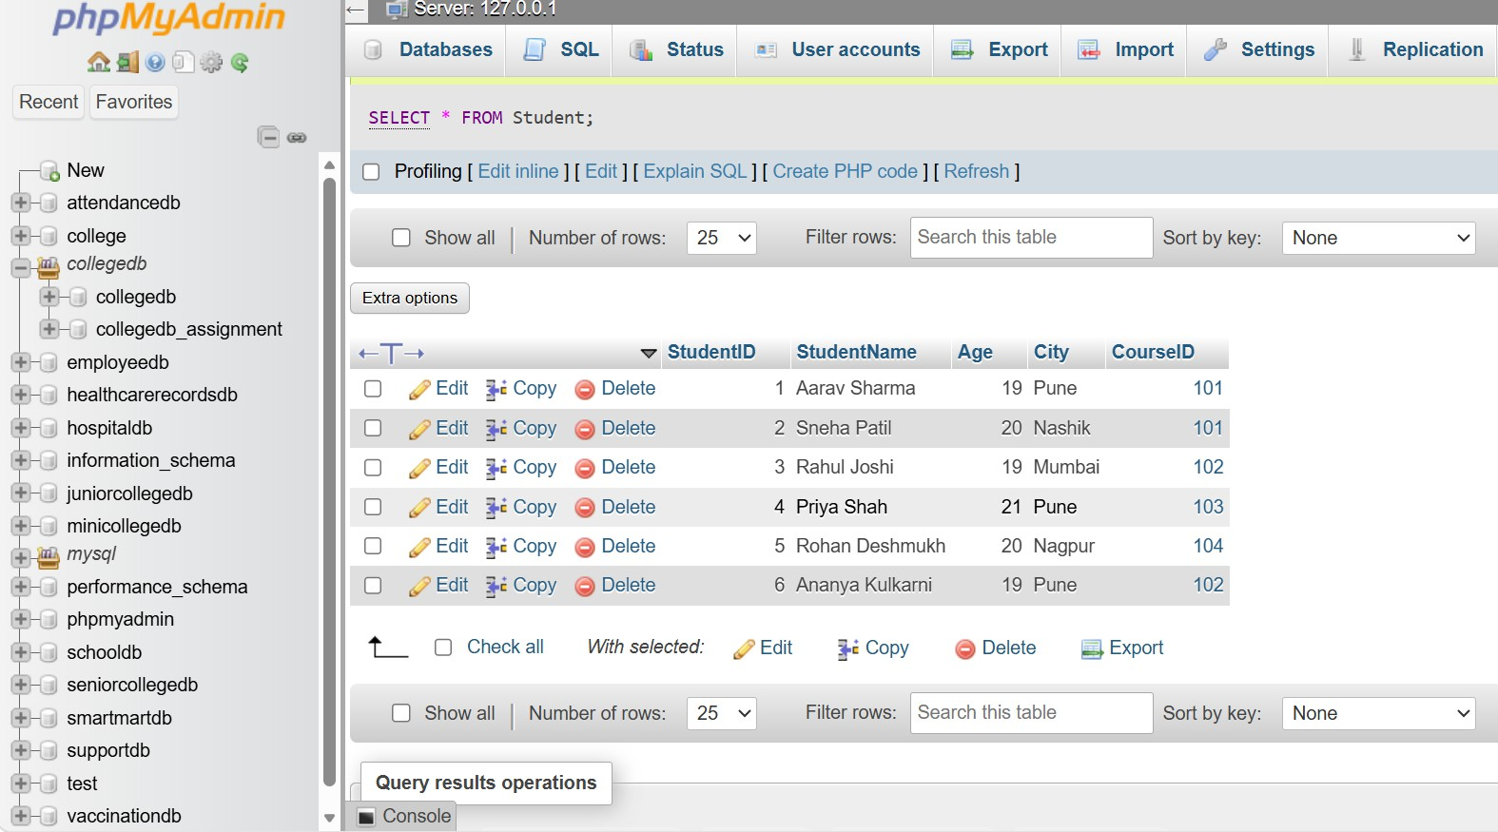

QUESTION 3
Q3) Write a MySQL query to insert one new student record into the Student table. The record should include: Field StudentID StudentName Age City CourseID

QUERY
INSERT INTO Student
(StudentID, StudentName, Age, City, CourseID) VALUES
(7, 'Vikram Singh', 20, 'Delhi', 101);

VERIFY:
Select * from student

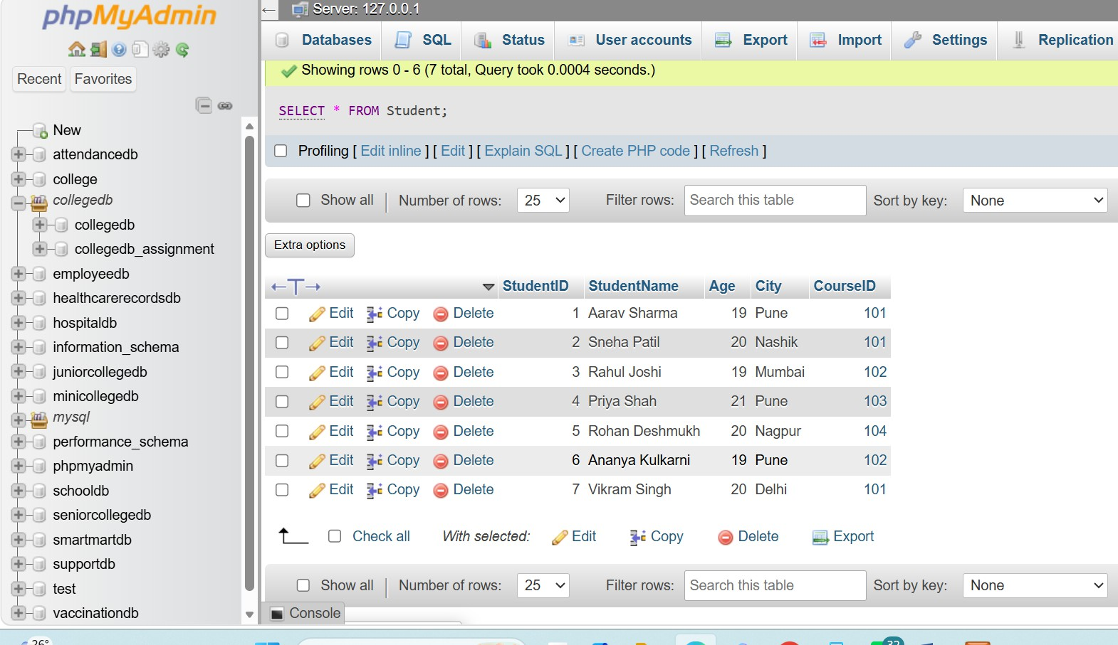

QUESTION 4
Q4) Write a MySQL query to update the city of a student using StudentID. Example requirement: Change Required Update the city of StudentID 2 to Mumbai

QUERY

UPDATE Student SET City = 'Mumbai'
WHERE StudentID = 2;

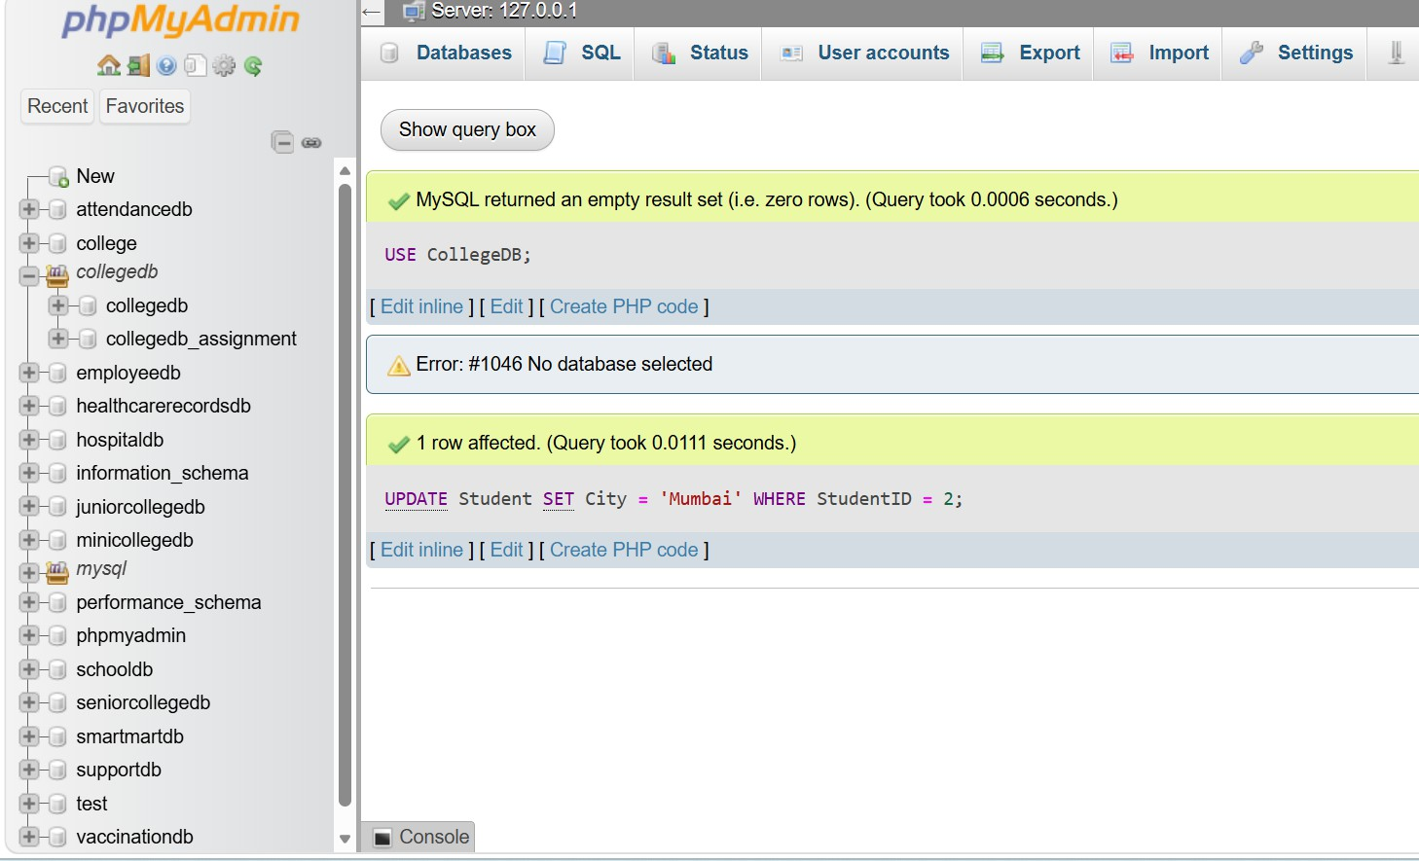

VERIFY:
Select * from student Where studnetID =2

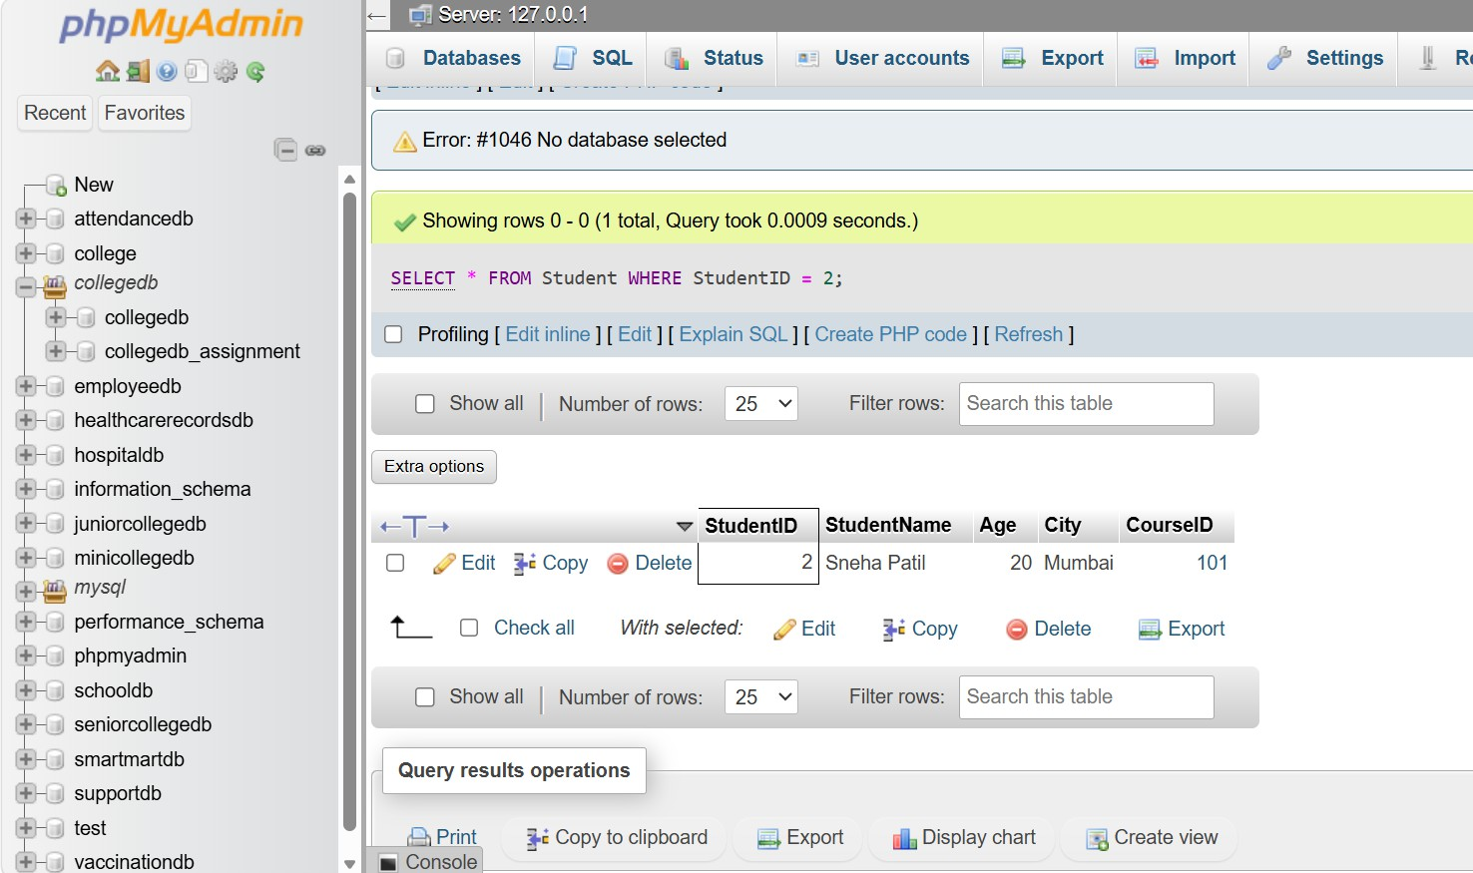

QUESTION 5
Q5) Write a MySQL query to update the fees of a course using CourseID. Example requirement: Change Required Update the fees of CourseID 101 to 47000

QUERY

UPDATE Course
SET Fees = 47000.00 WHERE CourseID = 101;

VERIFY:
Select * from COURSE Where studnetID =101;

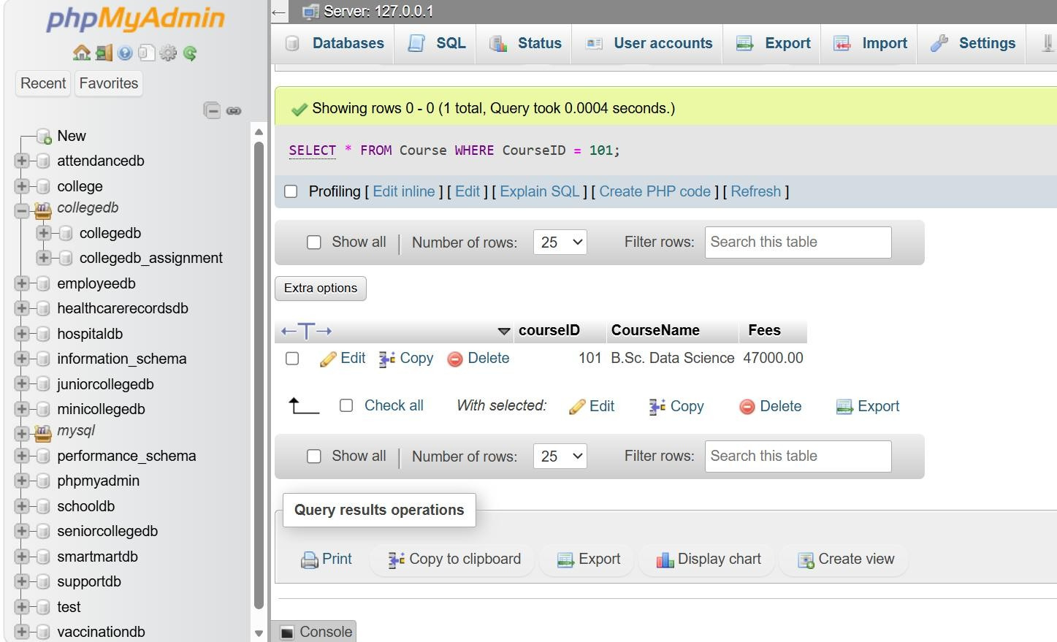

QUESTION 6
Q6) Write a MySQL query to delete one student record using StudentID. Also write one line explaining why the WHERE clause is important while using DELETE.

QUERY
DELETE FROM Student WHERE StudentID = 6;

VERIFY:
Select * from STUDENT

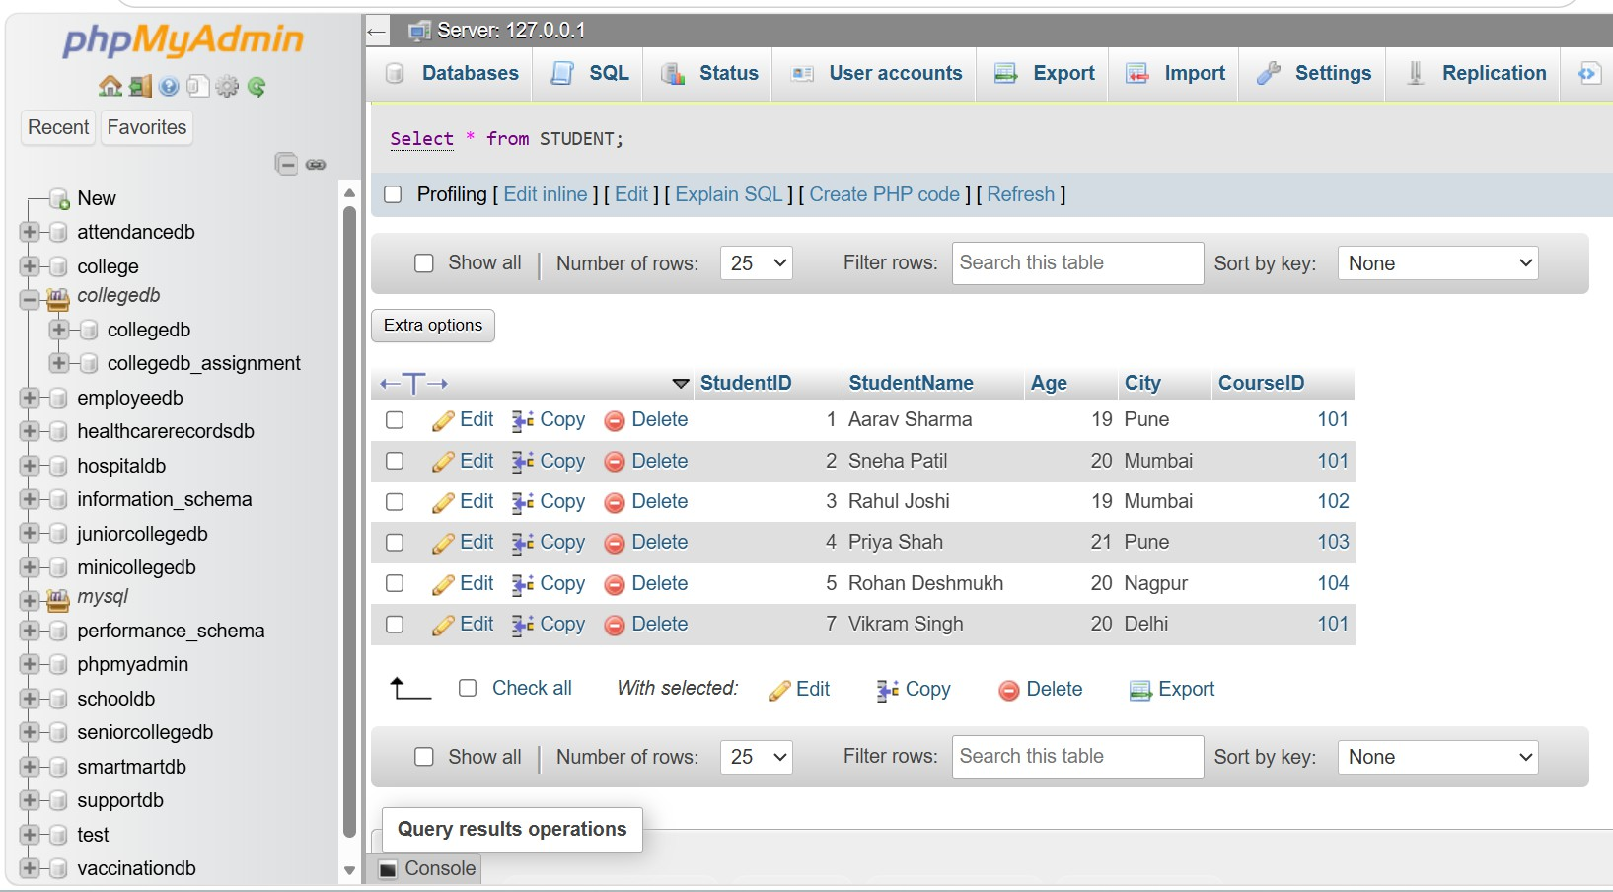

THE WHERE CLAUSE ENSURES THAT ONLY THE SPECIFIED STUDENT RECORD IS DELETED.
WITHOUT WHERE, ALL RECORDS FROM THE STUDENT TABLE WOULD BE DELETED.

